# Attendance Analysis (ChildPlus → Python → Power BI)

This project analyzes student attendance patterns using ChildPlus attendance exports, with a focus on:
- Absence rate differences between **homeless vs non-homeless** children
- Absence documentation completeness (missing absence reasons)
- Transportation-related absenteeism
- Income-group attendance patterns

# Data Coverage (High Level)

Attendance data was extracted from ChildPlus for multiple Program Years, including archived databases for historical years.
For presentation clarity, dashboards focus on the most recent years while keeping multi-year capability.

---

# Key Datasets

##1) complete_dataframe (daily-level attendance)
Typical fields:
- Attendance date
- Attendance status (present/absent)
- Absence reason code description
- Site / program / year attributes
- Flags like `IsAbsent`, `IsPresent`

# 2) `summary_dataframe` (child-level aggregated metrics)
One row per child (grouped by year/site/term), including:
- Total days, absent days, present days
- Absence rate
- Homeless status and income grouping

---

# Results Snapshot (example)

> These are **example** summary outputs (no raw records).

- `complete_dataframe` shape: **~679,599 rows x 29 columns**
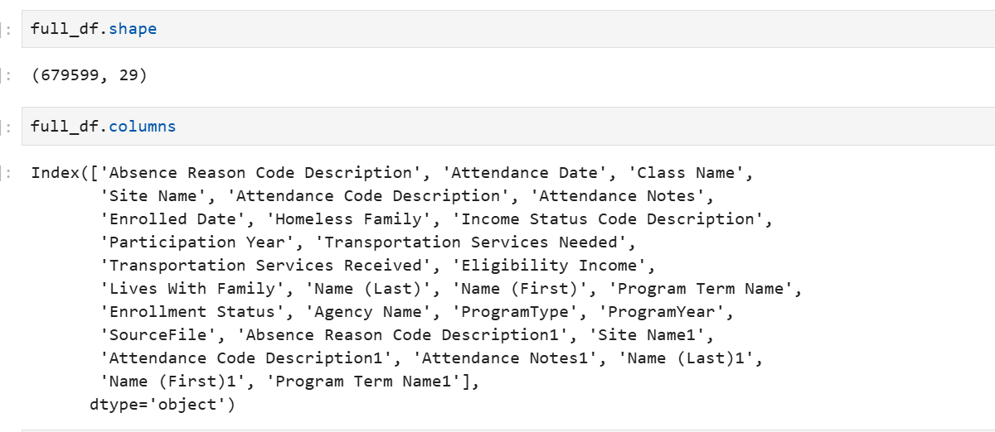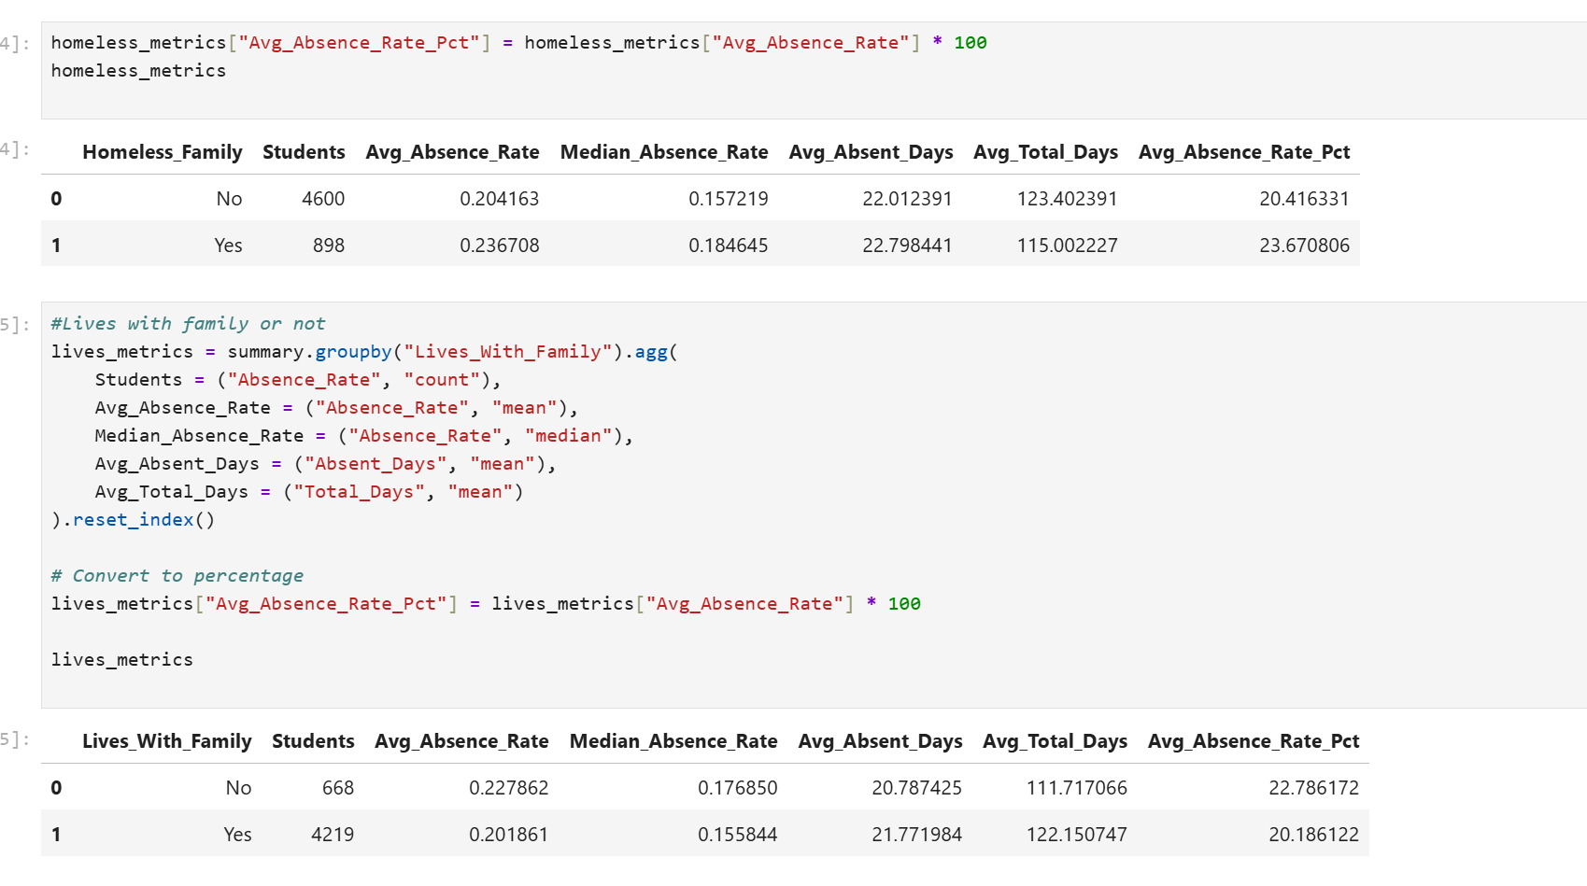
- Metrics computed:
Values have been masked to ensure data privacy
- Absence Rate (Homeless vs Non-Homeless):
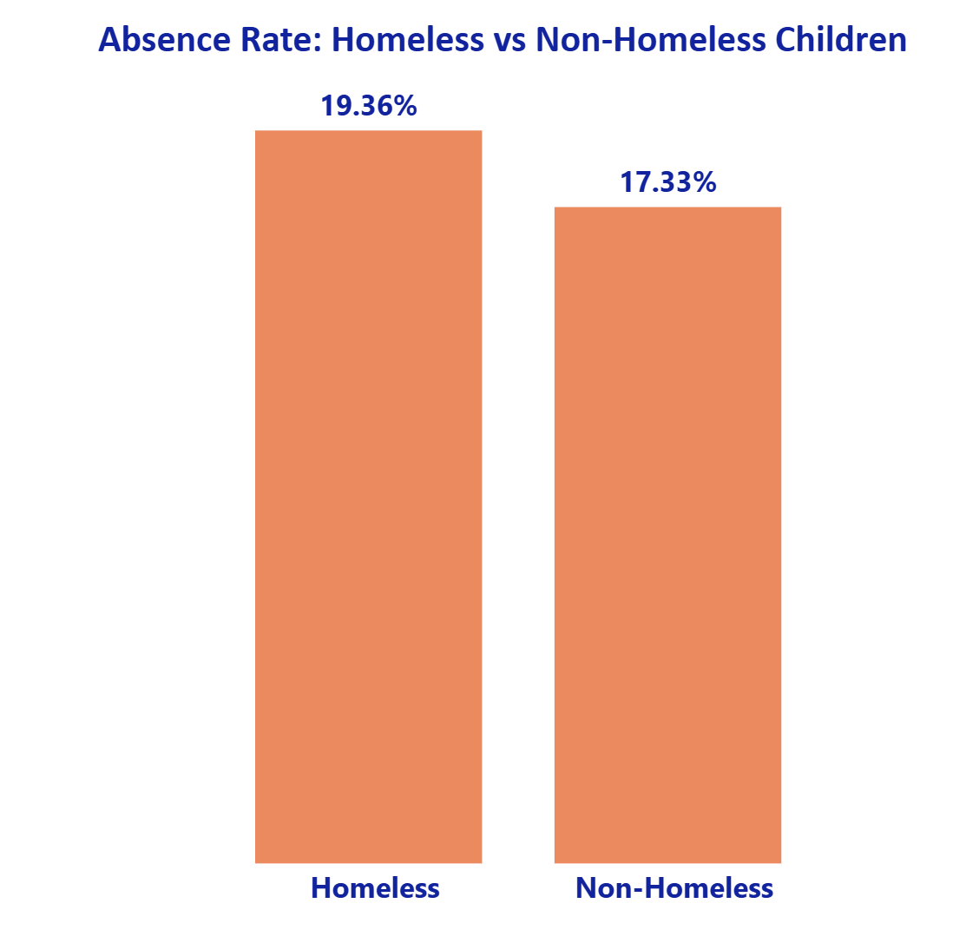
Recent Program Year: 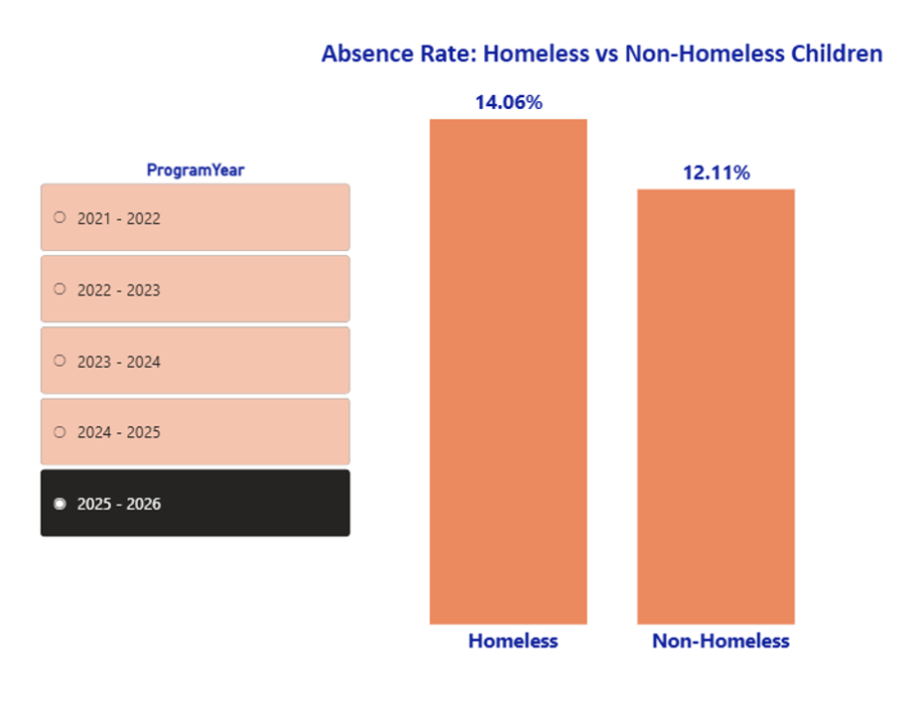
- Missing Absence Rate (overall and by site/year):
x-axis: Site Name
y-axis: Number of missing absence reasons
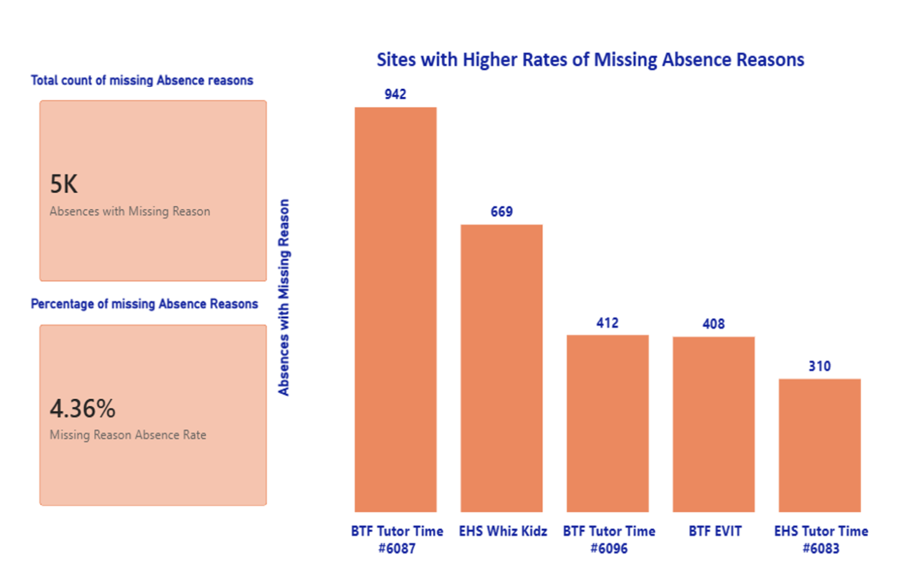
For this program Year: 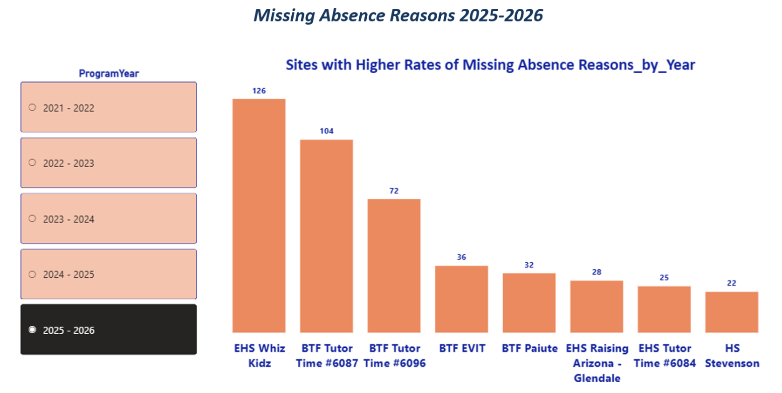

- Transportation-related absence rate by site/year:
y-axis: Site name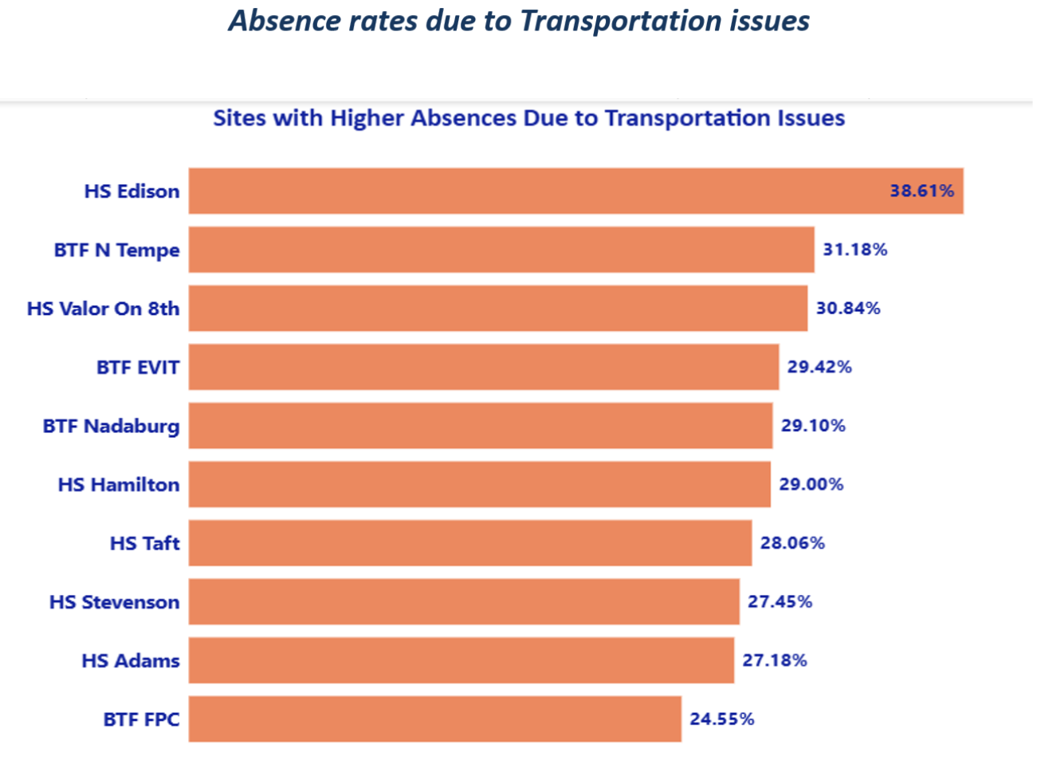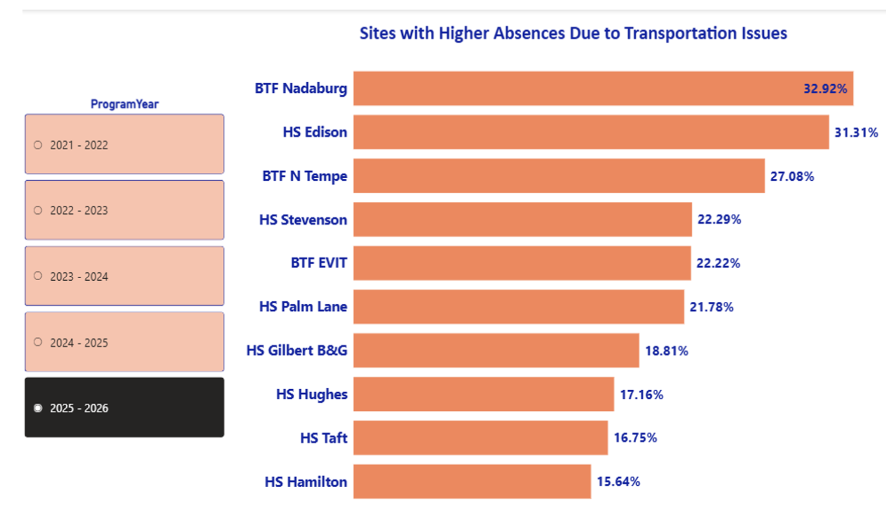
Previous two program years absence reasons:
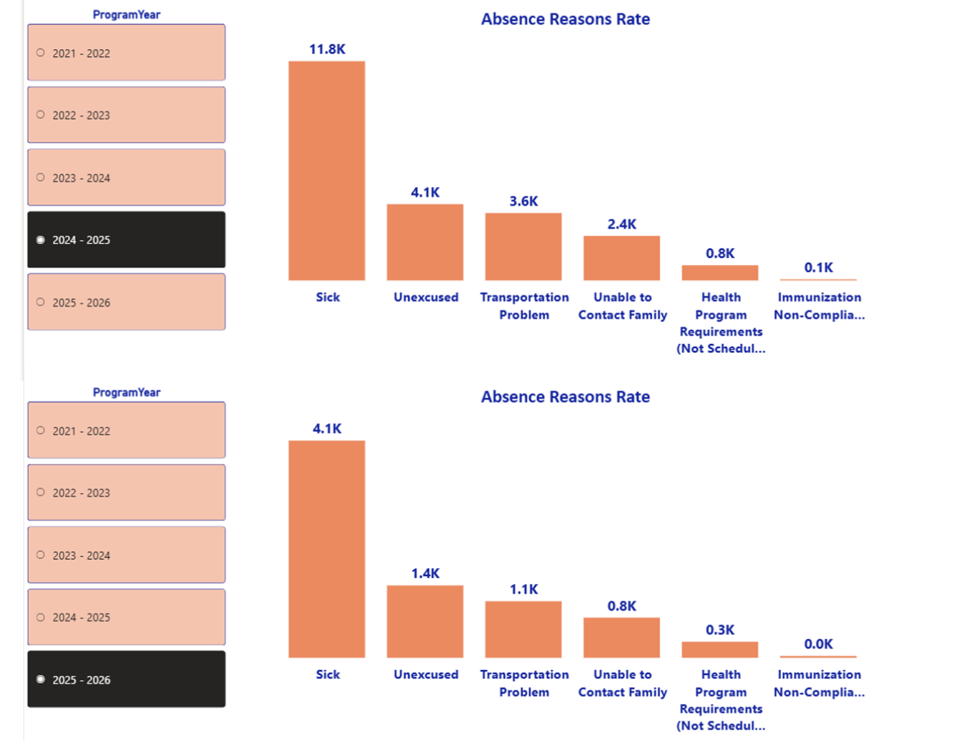
- Monthly absence trends:
